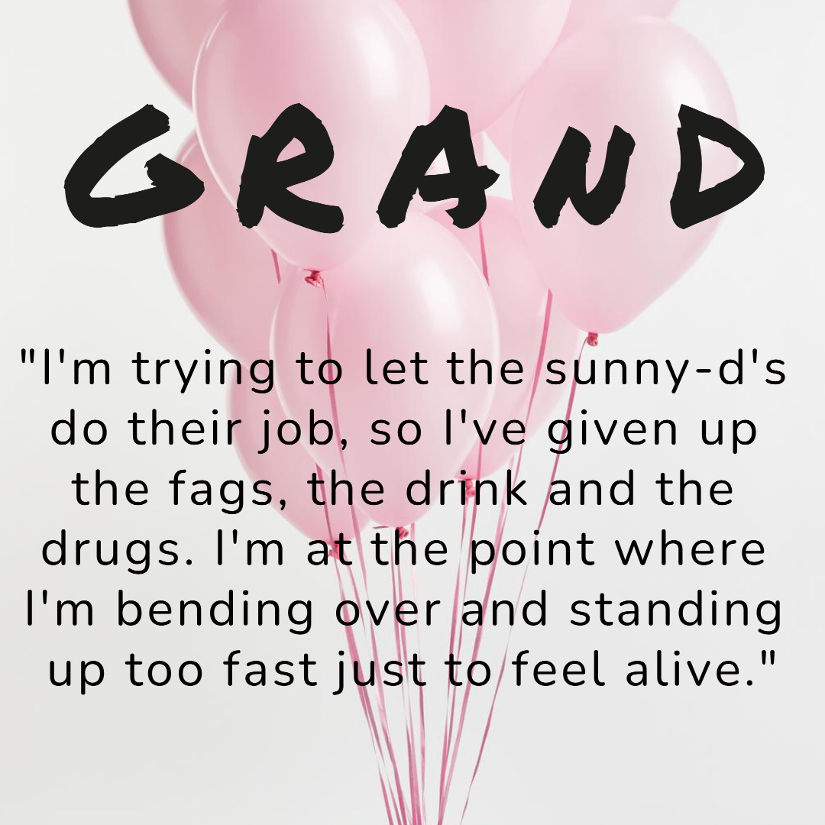

GRAND – A 2-Act dark comedy
“Laura is a workaholic juggling childhood trauma and an affair with her manager. Áine is a struggling artist with a gobshite ex and a Dublin flat she can't afford. Dearbhla is over her overdose and ready to mingle baby! The three women used to be best friends, until a falling-out fractured their relationship. Tonight they're locked together in a pressure cooker, trapped in an art gallery filled with their personal demons. A dark comedy that explores what ‘struggling’ really looks like, GRAND is a tale of three women, the deep affection they hold for one another, and how sometimes, something’s gotta blow.”

PAST PRODUCTIONS:-
PrimeCut Productions – Rehearsed reading staged 25th June 2021

